Comparison of bulk Sea Surface and Mixed Layer Temperatures

Semyon A. Grodsky, James A. Carton, and Hailong Liu

July 29, 2008
Revised for the Journal of Geophysical Research, Oceans

Department of Atmospheric and Oceanic Science
University of Maryland, College Park, MD 20742

Corresponding author:
senya@atmos.umd.edu

Abstract
Mixed layer temperature (MLT) and sea surface temperature (SST) are frequently used interchangeably or assumed to be proportional in climate studies. This study examines historical analyses of bulk SST and MLT from contemporaneous ocean profile observations during 1960-2007 for systematic differences between these variables. The results show that globally and time averaged MLT is lower than SST by approximately 0.1 ºC. MLT minus SST is even lower in upwelling zones where abundant net surface warming is compensated for by cooling across the base of the mixed layer. In the upwelling zone of the Equatorial East Pacific this negative MLT-SST difference varies out of phase with seasonal SST, reaching a negative extreme in boreal spring when SST is warm, solar radiation is high, and winds are weak. In contrast, on interannual timescales MLT-SST varies in phase with SST with small differences during El Niños as a result of low solar heating and enhanced rainfall. On shorter diurnal timescales, during El Niños, MLT-SST differences associated with temperature inversions occur in response to nocturnal cooling in presence of nearsurface freshening. Near surface freshening produces persistent shallow (a few meters depth) warm layers in the northwestern Pacific during boreal summer when solar heating is strong. In contrast, shallow cool layers occur in the Gulf Stream area of the Northwest Atlantic in boreal winter when fresh surface layers developed due to lateral interactions are cooled down by abundant turbulent heat loss. The different impacts of shallow barrier layers on near surface temperature gradients are explored with a one-dimensional mixed layer model.
1. Introduction
SST is a difficult parameter to define because the ocean has complex and variable vertical stratification complicated by the presence of laminar and turbulent boundary layers as well as varying meteorological fluxes. The most prolific measurements of SST are satellite radiance measurements, which sample the sub-millimeter skin temperature several times a day. Operational centers then modify these measurements based on comparison to in situ observations to produce gridded estimates of temperature of the upper ~1-5 m, referred to as the bulk SST (e.g., Reynolds and Smith, 1994; Reynolds et al, 2002; Rayner et al., 2003). But many applications, including studies of climate (Manabe and Stouffer, 1996; Deser et al., 2003; Seager et al., 2002), biogeochemical cycles (Doney et al., 2004), and fisheries (Block et al., 1997) require estimates of the average mixed layer temperature. In general we may expect MLT to be lower than SST by a few tenths of a degree. This difference reflects the time average effect of the nearsurface suppression of turbulence by daytime warming or by positive freshwater flux.

The upper 10 m of the ocean has complex and variable vertical temperature stratification. This variation in stratification occurs more frequently under conditions in which the ocean surface fluxes cause gains or losses of heat or freshwater or in situations of strong horizontal exchange. Surface fluxes are responsible for a distinct diurnal cycle in the temperature in the uppermost few meters over wide areas of the ocean when winds are weak and solar heating is strong [Stuart-Menteth et al., 2003; Gentemann et al., 2003; Clayson and Weitlich, 2007; Kawai and Wada, 2007]. This diurnal cycle is particularly prominent in upwelling areas such as the eastern equatorial Pacific where vertical advection of cool water leads to shallow stratification and thus shallow mixed layers (Deser and Smith, 1998; Cronin and Kessler, 2002). In the warm pool region of the western equatorial Pacific diurnal warming arises because the excess rainfall forms a nearsurface barrier layer of low salinity water even though the seasonal thermocline is rather deep [Soloviev and Lukas, 1997].

Impact of diurnal warming on SST is addressed by applying various corrections [see e.g. Donlon et al., 2007] assuming that the diurnal thermocline is destroyed by nocturnal convection. But, the diurnal cycle of temperature may be significantly altered over some oceanic regions affected by the surface freshening or upwelling where MLT differs seasonally from bulk SST. In this study we compare historical analyses of bulk SST by Rayner et al. [2003] and Smith and Reynolds [2003] with contemporaneous temperature and salinity profile observations to identify the conditions giving rise to systematic differences between mixed layer temperature and bulk SST and to identify the regions where this difference is essential. These historical analyses of bulk SST are widely used in climate studies and for ocean model validations. Although using bulk SST instead of satellite SST eliminates part of the diurnal warming signal that contributes to the deviation of MLT from skin SST, it also eliminates contribution of satellite SST bias. In this sense we focus on the difference between MLT that is simulated by majority of ocean models and the reference bulk SST that is used to validate ocean models.

The mixed layer is defined as the near-surface layer of uniform properties such as temperature and salinity. The presence of weak stratification and the nearness to atmospheric momentum sources give rise to values of the Richardson number consistent with flow instabilities and thus a high potential for turbulent motion. Under conditions where density is primarily determined by temperature de Boyer Montégut et al. [2004] (with a generalization introduced by Kara et al., 2000a) define the base of the seasonal mixed layer to be the depth at which temperature changes by 0.2C from its value at 10m reference depth. From this we can define a seasonal MLT as the vertical average temperature of the mixed layer, which when multiplied by the depth of the mixed layer and the specific heat of seawater gives the heat capacity of the layer of ocean in direct contact with the atmosphere on seasonal timescales.

The near surface processes that affect the monthly difference, dT=MLT-SST, are dominated by the integrated effect of diurnal warming. But, a variety of processes including rain, river discharge, or lateral interactions may produce fresh barrier layers that trap the heat near the surface by shoaling the penetration depth of wind stirring and nocturnal convection [Lukas and Lindstrom, 1991; Soloviev and Lukas, 1997]. Moreover, stable salinity profiles may permit nocturnal temperature inversions due to radiative cooling [Anderson et al., 1996; Cronin and Kessler, 2002] with magnitudes comparable to those of diurnal warming. Barrier layers are observed over wide ocean areas; in particular, they are produced by abundant rainfall and river discharge in the tropics, an excess precipitation over the North Pacific, and lateral exchanges across the western boundary currents [de Boyer Montégut et al., 2007]. In all these areas we also expect significant stratification of near surface layers that affect the difference between MLT and SST.

2. Data and Methods
The mixed layer properties for this study are estimated from individual temperature profiles provided by World Ocean Database 2005, WOD05 [Boyer et al., 2006], for 1960 through 2004. We use data from the mechanical bathythermographs (MBT), expendable bathythermographs (XBT), conductivity-temperature-depth casts (CTD), ocean station data (OSD), moored buoys (MRB), and drifting buoys (DRB). The final four years of the database contain an increasing number of profiles from the new Argo system (PFL). The Argo profiles through 2007 are obtained from the Argo Project web site. For better characterization of the tropical Pacific region, the data provided by the TAO/TRITON moorings [McPhaden et al., 1998] are also used.

The mixed layer depth (MLD) may be defined in a number of different ways. In this study we use the concept of the isothermal mixed layer depth that is evaluated from individual vertical profiles based on the temperature difference from the temperature at a reference depth of 10 m [de Boyer Montégut et al., 2004]. This reference depth was shown to be sufficiently deep to avoid aliasing by the diurnal signal, but shallow enough to give a reasonable approximation of monthly mixed layer depth. It is worth noting that in some areas of shallow mixed layer, such as the Black Sea, or in areas of strong upwelling, the thermocline may shoal above the 10m reference level. In these particular areas our estimates of MLD may be biased deep and estimates of MLT may be biased cold. In this study the isothermal MLD is defined as the depth at which temperature changes by |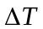| = 0.2ºC relative to its value at 10m depth. Following Kara et al. [2000a], the isothermal MLD is defined by the absolute difference of temperature, ||, rather than only the negative difference of temperature. Temperature inversions (>0) are most common at high latitudes. They are accompanied by stable salinity stratification to achieve positive water column stability, and, thus, may be used as an indicator of the base of the mixed layer. The same definition of isothermal mixed layer depth has been used by Carton et al. [2008] who show that the absolute temperature difference criterion works reasonably well even at high latitudes in the North Atlantic where the thermal stratification is relatively weak.

An alternative definition of the mixed layer depth (based on the dynamical stability criterion) defines it as the depth of a density uniform layer. Vertically-averaged temperature of the uniform temperature layer is the same as vertically averaged temperature of the uniform density layer if the latter layer is not deeper than the former (barrier layer). If a uniform density layer is deeper than a uniform temperature layer (density compensation), their average temperatures may be different. Here we follow de Boyer Montégut et al. [2004] and define the mixed layer as a layer vertically uniform in both temperature and salinity. Hence, the mean mixed layer temperature is the same as the mean temperature of an isothermal layer. The mean temperature of an isothermal layer is referred in this study as the mixed layer temperature.

The mixed layer temperature is evaluated as the temperature vertically averaged above the base of the mixed layer using trapezoidal numerical integration, assuming uniform temperature above the reference depth, 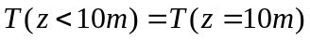. Vertical sampling of temperature varies from approximately 10m for low resolution MBTs to approximately 1m for high resolution sensors, such as CTDs. The method of vertical integration chosen is not important because the MLT is evaluated over the layer quasi-homogeneous in temperature. By assuming temperature constant above 10m a large portion of daytime heat gain is excluded that makes MLT estimates appear more like nighttime vertically averaged temperature. We introduce this assumption in order to make use of XBT and Argo data that constitute a good portion of the ocean profiles inventory. In their current configuration these two instruments are not designed to sample the upper few meters below the surface. In particular, the Argo floats don’t sample the upper 5m of the ocean while the upper 4m XBT temperature is biased by ‘start-up’ adjustment [Kizu and Hanawa, 2002]. After estimating MLT at each profile location we then apply subjective quality control to remove ‘bulls eyes’ and bin the data into 2ºx2ºx1mo bins with no attempt to fill in empty bins.

Mixed layer temperature is compared with bulk SST provided by Met Office Hadley Centre sea ice and sea surface temperature (HadISST1) of Rayner et al. [2003] and by extended analysis (version 2) of Smith and Reynolds [2003]. Both products provide globally complete monthly averaged grids spanning the late 19th century onward. HadISST1 combines a suite of historical and modern in situ near surface water temperature observations from ships and buoys with the recent satellite SST retrievals, while the Smith and Reynolds [2003] data is mostly based on in-situ measurements. Neither of these products use the vertical temperature profiles from WOD05. In order to reduce the impact of diurnal effects the UK Met Office HadISST1 utilizes only the night satellite SSTs (available beginning in 1981) and adjusts them to match in-situ measurements collected by voluntary observing ships, drifters, and buoys (Rayner et al. 2003). The NOAA National Climatic Data Center SST extended analysis uses both day and night satellite SSTs only to evaluate the spatial structure of analysis SST while relying on the same in situ observations to adjust their SST analysis to reflect water temperature at an effective depth of ~1-5 m (Smith and Reynolds 2003). A more precise definition of this analysis depth is impractical for either product because of the variety of depths at which the in situ observations are available. SST adjusted to temperature at a few meters depth is referred to here and after as bulk SST or simply SST. Adjustment to measurements taken from a few meters depth (where the diurnal signal is relatively weak) effectively attenuates but doesn’t eliminate impacts of transient near surface processes on bulk SST completely. Most recently the Global Ocean Data Assimilation Experiment High Resolution SST Project has introduced the concept of ‘foundation SST’, defined as the temperature at a depth of 10m, below the depth of the diurnal cycle. But this 10m depth temperature, which generally lies within the mixed layer, has not been measured frequently enough to calibrate the analyses.

The local response of the mixed layer to the forcing from the atmosphere is simulated using the one-dimensional hybrid mixed layer model of Chen et al. [1994]. This model is based on the Kraus-Turner-type bulk mixed layer physics for the first shallowest layer. This first layer depth is determined by a turbulent energy balance equation and its temperature and salinity are determined by budget equations forced by surface fluxes and entrainment. The entrainment across the base of the first layer provides a communication between the mixed layer and the ocean beneath that is represented in sigma-layers. This model is capable of simulating the three major mechanisms of vertical turbulent mixing in the upper ocean wind stirring, shear instability and convective overturning. The model is forced by 6-hour surface fluxes provided by the NCEP/NCAR atmospheric reanalysis of Kalnay et al. [1996].

3. Results
We begin by examining the average 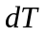 based on the 1960-2004 WOD05 dataset (Fig. 1a). Because of the distribution of observations, only the Northern Hemisphere is well sampled. On average, MLT is colder than bulk SST by about 0.1ºC, with large anomalies <-0.4°C north of the Kuroshio-Oyashio extension and along the Equator in the eastern Pacific, and large anomalies >0.4°C anomalies (temperature inversions) in the Gulf Stream region.The results are similar for the two bulk SST analyses, but only results based on HadISST1 are shown in Fig.1. The equatorial Atlantic shows negative anomalies as well, but not as large as those in the equatorial Pacific. Spatial patterns of don’t change much if a density-based mixed layer depth is used (compare Figs. 1a and 1b), but data coverage is reduced due to a lack of salinity data.

To illustrate the relationship between MLT and bulk SST in the Southern Hemisphere we examine averaged using Argo profile data set which, although is more homogenous spatially, is mainly restricted to 2004onward (Fig. 1c). The Argo results in the Northern Hemisphere show only a few differences from the distribution of based on the WOD05 data set. In the Labrador Sea positive values of are now more evident, indicating nearsurface temperature inversions. In contrast, the subtropical North Atlantic and North Pacific both show negative values in the regions of weak winds where diurnal warming of the nearsurface is a frequent occurrence. In the Southern Hemisphere large negative anomalies of dT based on Argo data are evident in the South Pacific west of Chile as well as southwest of Australia and South of Cape of Good Hope. We next focus on the Northern Hemisphere patterns because they are evaluated from longer time records than those from the southern counterparts. To explore the causes of the largest anomalies of we next examine in detail the time changes in the three regions in the Northern Hemisphere identified in Fig. 1.

These three regions are distinguished by persistently shallow nearsurface stratification due to either upwelling or impact of the barrier layers (nearsurface freshening) that trap warming (cooling) in the near surface. On the other hand, the air-sea interactions are particularly strong over these regions. It is illustrated by climatological maps of the net surface heat gain by the ocean. During the northern winter (Fig. 2a) the turbulent heat loss in excess of 200 Wm⁻² occurs over the warm western boundary currents in the Pacific and in the Atlantic due to strong air-sea temperature contrast which leads to enhanced evaporation and sensible heat loss over areas of warm SSTs. In northern summer (Fig. 2b) the ocean gains heat in excess of 100 Wm⁻² in the northwestern Pacific and over the shelf waters north of the Gulf Stream. While the seasonal increase in the ocean heat gain in summer is explained by the seasonal cycle of insolation, the geographical location of the areas of strong ocean heat gain is linked to the spatial patterns of SST. Both areas of strong ocean heat gain in the north Pacific and Atlantic Oceans are located to the north of sharp SST fronts. Although solar radiation decreases gradually with latitude, the evaporation decreases abruptly across the SST front. As a result of these spatial changes the ocean gains more heat north of the subtropical SST front in the Pacific and north of the Gulf Stream north wall in the Atlantic (Fig. 2b). The ocean also gains heat at a rate exceeding 100 Wm⁻² in the eastern equatorial Pacific cold tongue (Fig. 2b) due to abundant solar radiation and relatively weak local latent heat loss over cool SSTs in the cold tongue. In the cold tongue the heat gain is compensated by entrainment cooling. In the near surface it produces remarkable magnitudes of diurnal warming. We shall next analyze the origins of persistently shallow stratifications in these three regions.

3.1 Eastern Equatorial Pacific
The equatorial Pacific thermocline shoals eastward in response to annual mean easterly winds that, along with entrainment cooling, form a tongue of cool water in the east. Here, in the cold tongue, the ocean gains heat from the atmosphere in excess of 100 Wm⁻² (Fig.2b) that is compensated by entrainment cooling. In response to this surface heat flux the near-surface ocean develops substantial diurnal warming of SST, in excess of 0.2°C [Deser and Smith, 1998]. Here, average is approximately -0.4ºC (Fig. 3a) with more negative values (MLT<SST) in March when SST reaches its monthly maximum and diurnal warming is large (Fig. 3b) [Cronin and Kessler, 2002]. In contrast, on interannual timescales is weak (MLTSST) when El Niño warms SST, the mixed layer deepens, solar radiation decreases and freshwater input increases, and has negative extreme during the La Niñas when the mixed layer shoals and atmospheric convection shifts westward [Cronin and Kessler, 2002; Clayson and Weitlich, 2005]. In Fig.3a this relationship is clearest after the early 1980s as the data coverage increases.

In order to understand the causes of the seasonal and interannual relationships we examine conditions at the Tropical Atmosphere Ocean/TRITON mooring at 0°N, 140°W for 1995-2001, encompassing the 1997-98 event (Fig. 4a). We focus on 0°N, 140°W location, where the records are continuous during the event. At this location 1m temperature, a proxy for SST, increases by 5°C during 1997 and then decreases by nearly 7°C in mid-1998. Coinciding with the drop in 1m temperature is a substantial development of negative meaning that the mixed layer has developed some near-surface temperature stratification. The negative values of are even more striking in 1999 and 2000 when SST increase during January-March as part of the climatological seasonal cycle at this location phases with interannual variation of .

To identify the mechanisms giving rise to differences in seasonal and ENSO changes in we examine a one-dimensional mixed layer model simulation beginning with homogeneous initial conditions (Fig. 4b). The model is forced by fluxes from the NCEP/NCAR reanalysis. These fluxes are known to have errors in shortwave radiation and other components. But comparison of the reanalysis fluxes with measurements taken at the 0N, 140W TAO/TRITON mooring indicates that reanalysis fluxes provide reasonable variability associated with ENSO (Fig.4). The model responds seasonally to weakened winds in boreal spring (Fig. 4d) with increased near-surface stratification (<0) as observed. The conditions arising during the onset of El Niño similar to those occurring during the first half of 1997 are somewhat different. During those months the winds also weakened, but solar heating decreased (Fig. 4c) and freshwater input increased (Fig. 4d) as a result of the eastward shift of convection. The decrease in the ocean heat gain due to decreased solar heating is accompanied by increased latent heat loss due to warmer SST (Fig. 4c). The result is weakening values of followed in the summer and fall by occasional temperature inversions. In mid-1998 through early 1999, as El Niño transitioned into cooler La Niña conditions, the nearsurface again becomes strongly stratified due to enhanced solar heating and weaker latent heat loss and resulting diurnal warming of the nearsurface. Good comparison between one-dimensional mixed layer model simulation and observed suggests that the processes governing are one-dimensional and include local response of the mixed layer to changes in wind forcing and heat flux.

Intermittent temperature inversions (SST cooler than MLT by 0.2-0.5°C) are evident in observations (Fig. 4a) and simulations (Fig. 4b). They are associated with nocturnal cooling of shallow freshwater lenses produced by enhanced rainfall (Fig. 4d). Stable salinity stratification (barrier layer) produced by local rainfall captures the nocturnal convection in the near surface layer until the cooling or wind stirring is strong enough. If the freshwater surface flux is set to zero, the one- dimensional model doesn’t simulate temperature inversions [see also Anderson et al., 1996].

As we have seen the stable salinity stratification produced by local rainfall may impact significantly the near surface temperature stratification. An alternative mechanism of barrier layers formation is associated with the lateral interactions. In particular, in the equatorial Pacific near the dateline, salty and warm water can be subducted under the western Pacific’s warm fresh water to form barrier layers [Lukas and Lindstrom, 1991]. This advection mechanism, which is not in an one-dimensional model’s physics, may be effective near the frontal interfaces and contribute to temperature inversions during the seasons when the ocean loses heat.

3.2 Gulf Stream
In the western North Atlantic, MLT differs from bulk SST along the Gulf Stream path (Fig. 1). This regional anomaly may result from differences in spatial interpolation of MLT and bulk SST that may be an issue in regions of sharp SST fronts. To eliminate the potential impact of spatial interpolation, the MLT-SST is also computed from individual CTD and Argo profiles (Fig. 5). This reveals noticeable seasonal variation of MLT-SST that is not expected if the difference in spatial interpolation dominates the signal. In summer, MLT is colder than bulk SST in the cold sector of the Gulf Stream front due to abundant net surface heating and relatively weak evaporation over cool SSTs (Fig. 5a). Analysis of vertical profiles (Fig.6a) indicates that this heating produces a warm layer trapped in a 10-20m deep shallow fresh layer. This shallow barrier layer limits the depth of nocturnal convection and mechanical stirring above the base of halocline and thus separates the shallow near surface warm layer (that is still observed at 2 a.m. local time) from the seasonal mixed layer. This shallow warm layer affects water temperature in the depth range of 1-5m used to adjust the bulk SST analysis. This, in turn, explains the cold difference between MLT and bulk SST observed north of the Gulf Stream north wall in summer. Negative in this region is statistically significant and shows up in the tail of the regional histogram (Fig.1a).

In contrast, an examination of the spatial structure of MLT-SST during the winter months (Fig. 5b) shows large inversions frequently exceeding 1°C along the path of the Gulf Stream, while SST is close to MLT in this area in summer. Winter MLT-SST inversions are aligned along the northern wall of the Gulf Stream (Fig. 5b), suggesting mechanisms involving cross-frontal interactions between contrasting water masses. Collision of warm and salty Gulf Stream water with colder and fresher shelf water produces shallow salinity stratified cold near-surface layers (Fig. 6b). These layers are further cooled by oceanic net surface heat loss and eventually destroyed by passing storms. In spite of that, the ocean areas affected by the temperature inversions might be more frequently observed by satellite infrared sensors. In fact, passing winter storms that eventually destroy the inversions are usually associated in the Gulf Stream area with the cold air outbreaks and significant convection cloudiness that obscure infrared imageries of the sea surface. Winter MLTs warmer than SSTs are observed over a spatially narrow area along the Gulf Stream north wall. As a result, their contribution is not seen in the shape of histogram evaluated over a wider area shown in Fig.5b.

Examination of the meridional variations of also shows the strongest temperature inversions over the warm Gulf Stream (Fig.2c). Variations of are similar if an alternative, gradient-based definition of the mixed layer depth is used (Fig.2c). Seasonal variations of MLT-SST in the Gulf Stream region occur in accord with the seasonal variations of the net surface flux that displays very large heat loss over the warm Gulf Stream in winter (e.g. Dong and Kelly, 2004) and strong warming over the cold shelf sector in summer. In distinction from the equatorial Pacific, where interannual significantly correlates with local SST, these values are weakly correlated in the Gulf Stream area (Fig. 3c).

The above discussions emphasize impacts of salinity on the near-surface temperature stratification. Next, the temperature response to the presence of the near-surface salinity gradients (occurring in the Gulf Stream area) is explored with a one-dimensional mixed layer model (Fig. 7). To contrast the impact of salinity, the twin runs are compared. Each pair of model runs is forced by the same fluxes but differs in initial conditions. The first (control) run starts from the vertically homogeneous temperature and salinity while the initial salinity profile for the second run has salinity decreasing toward the surface in the upper 20 m at a rate of 0.1 psu m⁻¹ (in accord with observations in Fig. 6).

Fig. 7b illustrates simulations during the warm season. It displays the difference in temperature between the two runs that shows an impact of the near surface freshening. In the presence of a stabilizing salinity gradient the diurnal warming is stronger during the first day of simulations (Fig. 7b), but is surprisingly similar during the second day when it is limited by the shear instability of diurnal currents. Relative warming in the upper 20 m is even stronger as wind strengthens. This is explained by slower deepening of the mixed layer and weaker entrainment cooling in the salinity-stratified case. Although the one-dimensional mixed layer model simulates warmer near-surface temperature in the salinity-stratified case, the simulated temperature stratification in the upper 10 m column doesn’t exceed a few tenths of a degree in contrast with observations (Fig. 6a). This is explained in part by relatively short (only a few days long) run as well as by limitations of the model. If a strong (1 day) relaxation of salinity to its initial conditions is introduced (to account indirectly for three-dimensional mechanisms producing a shallow halocline) the temperature gradient in the upper 10m amplifies up to 1ºC but never reaches values shown in Fig. 6a.

In winter the mixed layer model simulates a 1ºC colder mixed layer in salinity stratified case than in the control run (Fig. 7d). The difference is due to the stably stratified halocline that limits the penetration depth of wind stirring. In turn, the shallower mixed layer cools down faster due to net surface heat loss. Although the anomalous cooling of 1ºC compares well with observations (Fig. 6b), the simulated mixed layer is relatively deep. Therefore, the stratification is weak in the upper 10 m in contrast to observations. This suggests again that lateral interactions (missing from the one-dimensional model) are important for establishing winter temperature inversions in the region, while the net surface heat loss further amplifies existing anomalies.

3.3 Northwestern Pacific
Salinity in the Northwestern Pacific decreases towards the surface. This stable halocline is produced by an annual-mean excess of precipitation over evaporation north of 30°N and is maintained by upward vertical pumping driven by a cyclonic wind curl [Kara et al., 2000b]. Although the regional precipitation peaks in winter, the near-surface freshening persists year -round. In summer, when the ocean heating is particularly strong (Fig. 2b), the shallow stably stratified halocline localizes the ocean heat uptake in the near-surface layer (Fig.1) by limiting the penetration depth of wind stirring and nocturnal convection. In distinction from the Gulf Stream region, where shallow warm layers develop mostly in the cold sector of the front, the shallow warm layers are observed randomly in the Northwestern Pacific (Fig.5c). They are not destroyed by nocturnal convection (see sample profile taken at 10 p.m. local time, Fig. 8). Meridional variations of follow the meridional variations of net surface heating and are similar if different a gradient-based definition of the mixed layer depth is used (Fig. 2d). Occasional SST inversions seeing in Fig. 5c are associated with nocturnal cooling of freshwater lenses (profiles are not shown).

Shallow warm layers observed in the Northwestern Pacific and in the Gulf Stream region in summer are not observed in winter when the ocean loses heat to the atmosphere (Figs. 5b and 5d). During that season mixed layer temperatures warmer than SSTs are observed along the Gulf Stream north wall (Fig. 5b) where the combination of strong heat loss and strong spatial gradient of salinity results in cooling of the near-surface salinity stratified layers. Despite similarly strong heat loss over the warm western boundary currents in the Atlantic and Pacific Oceans (Fig. 2a), the winter SST inversions are less frequently observed in the Kuroshio region in distinction from the Gulf Stream region (Fig.1). This difference may be linked to the differences in spatial patterns of salinity. In fact, the spatial gradients of salinity, vital in producing the temperature anomalies, are significantly weaker in the Northwestern Pacific compared to the Northwestern Atlantic (see Fig.9 based on data from Antonov et al., 2006). There also appears to be some evidence in Fig.1 that the >0 seen in the Gulf Stream region also occurs in the Kuroshio region southeast of Japan where the salinity gradient is stronger (Fig.9). This area of temperature inversions (>0) is weaker and narrow in scope than in the Atlantic. In addition to the basin difference in salinity other factors such as boundary current behavior could also contribute to the structures in these regions.

4. Summary
This study compares the magnitudes of two ocean temperature variables frequently used in climate studies, mixed layer temperature and bulk SST as represented by the widely used analyses of Rayner et al. [2003] and Smith and Reynolds [2003]. Mixed layer temperature is defined as the vertically averaged temperature above the mixed layer base, and the depth of the base here is defined following Kara et al. [2000a] and de Boyer Montégut et al. [2004] as a function of the temperature difference relative to 10m temperature. Our analysis shows that areas with shallow temperature stratification, such as upwelling zones, frequently have significant differences between mixed layer temperature and SST. Shallow temperature stratification also occurs in regions of near surface freshening (barrier layers) which limits the depth of convection and wind stirring. In both cases, shallow stratification occurs in zones of strong air-sea heat exchange. In the Northern Hemisphere the local peaks of heat gain by the ocean are observed in local summer over the areas of equatorial cold tongues and over the areas of cold SSTs to the north of the Kuroshio Extension front and the Gulf Stream north wall. But, in winter, the ocean loses much heat over the warm SSTs of the western boundary currents.

We examine the temporal relationship between bulk SST and MLT in the Equatorial Eastern Pacific where abundant net surface warming is compensated for by cooling across the base of the mixed layer. Here MLT is persistently cooler than SST by approximately -0.4ºC. On seasonal time scales, it has a negative extreme during the boreal spring warm season when winds are weak. In contrast, on interannual timescales, the magnitude of = MLT-SST increases during La Ninas and weakens during El Niños as a result of increases/decreases in solar radiation and decreases/increases in precipitation. Increased precipitation during El Niños produces freshwater stratified barrier layers leading to nocturnal cooling.

In the subtropics negative values of are found in the Gulf Stream area of the western North Atlantic. In summer the shallow warming in excess of 1 ºC develops above the cool shelf waters to the west and north of the Gulf Stream where the ocean gains heat at a rate exceeding 100 Wm⁻². The presence of nearsurface freshening prevents the nighttime destruction of this shallow warm layer. In contrast, during winter the near surface layer within the Gulf Stream itself has an inverted temperature structure (time averaged dT=0.6°C) as the result of strong surface cooling in the presence of a near-surface barrier layer.

Another region where the salinity stratified barrier layers are present is the Kuroshio Extension region of the Northwest Pacific. Here the barrier layer is produced due to excess of precipitation accompanied by upward Ekman pumping preventing the vertical exchange of this freshwater. As in the case of the Gulf Stream region, the ocean gains heat in the summer at a rate exceeding 100 Wm⁻² producing a warm surface layer during the day which has time averaged of -0.5 ºC. In winter, MLT and SST match in this region.

One of the persistent issues in coupled atmosphere-ocean general circulation models is a tendency to develop cold biases in the eastern equatorial Pacific [Davey et al. 2002]. However the surface temperature of such models is actually more analogous to mixed layer temperature since the uppermost ocean grid point is well below the ocean surface, and diurnal processes are generally neglected. Thus, any systematic differences in SST and MLT are likely to be reflected in the evaluation of model SST bias. Indeed, Danabasoglu et al. [2006] have shown that adding the diurnal cycle to the daily mean incoming solar radiation does warm the model eastern equatorial Pacific SST and shoals the ocean boundary with SST observations similarly to observations. Even greater improvements to model SST estimates seem possible if the nearsurface stratification of temperature and salinity can be more accurately represented.

Acknowledgements. We gratefully acknowledge the Ocean Climate Laboratory of the National Oceanographic Data Center/NOAA, under the direction of Sydney Levitus, for providing the database upon which this work is based. Mixed layer temperature estimate based on the Lorbacher et al. [2006] approach has been downloaded from the web site maintained by Dietmar Dommenget, IFM-GEOMAR. Support for this research has been provided by the National Science Foundation (OCE0351319) and the NASA Ocean Programs. Comments by anonymous reviewers were very helpful.
References
Antonov, J. I., R. A. Locarnini, T. P. Boyer, A. V. Mishonov, and H. E. Garcia (2006), World Ocean Atlas 2005, Volume 2: Salinity. S. Levitus, Ed. NOAA Atlas NESDIS 62, U.S. Government Printing Office, Washington, D.C., 182 pp.
Anderson, S.P., R.A. Weller, and R.B. Lukas (1996), Surface Buoyancy Forcing and the Mixed Layer of the Western Pacific Warm Pool: Observations and 1D Model Results. J. Climate, 9, 3056–3085.
Block, B. A., J. E. Keen, B. Castillo, H. Dewar, E. V. Freund, D. J. Marcinek, R. W. Brill and C. Farwell (1997), Environmental preferences of yellowfin tuna (Thunnus albacares ) at the northern extent of its range, Marine Biology, 130, 119-132, doi: 10.1007/s002270050231.
Boyer, T.P., J.I. Antonov, H.E. Garcia, D.R. Johnson, R.A. Locarnini, A.V. Mishonov, M.T. Pitcher, O.K. Baranova, and I.V. Smolyar (2006), World Ocean Database 2005. S. Levitus, Ed., NOAA Atlas NESDIS 60, U.S. Government Printing Office, Washington, D.C., 190 pp., DVDs.
de Boyer Montégut, C., G. Madec, A. S. Fischer, A. Lazar, and D. Iudicone (2004), MLD over the global ocean: An examination of profile data and a profile-based climatology, J. Geophys. Res., 109, C12003, doi:10.1029/2004JC002378.
de Boyer Montégut, C., J. Mignot, A. Lazar, and S. Cravatte (2007), Control of salinity on the mixed layer depth in the world ocean: 1. General description, J. Geophys. Res., 112, C06011, doi:10.1029/2006JC003953.
Carton, J.A., S. A. Grodsky, and H. Liu (2008), Variability of the Oceanic Mixed Layer 1960-2004, J. Climate, 21, 1029–1047.
Chen, D., L.M. Rothstein, and A.J. Busalacchi (1994), A hybrid vertical mixing scheme and its application to tropical ocean model, J. Phys. Oceanogr., 24, 2156-2179.
Clayson, C.A., and D. Weitlich (2007), Variability of Tropical Diurnal Sea Surface Temperature. J. Climate, 20, 334–352.
Cronin, M.F., and W.S. Kessler (2002), Seasonal and interannual modulation of mixed layer variability at 0N, 110W, Deep-Sea Research I, 49, 1–17.
Danabasoglu, G., W.G. Large, J.J. Tribbia, P.R. Gent, B.P. Briegleb, and J.C. McWilliams (2006), Diurnal Coupling in the Tropical Oceans of CCSM3. J. Climate, 19, 2347–2365.
Davey, M. K., and coauthors (2002), STOIC: A study of coupled model climatology and variability in tropical ocean regions. Clim. Dyn., 18, 403-420.
Deser, C. and C. A. Smith (1998), Diurnal and semidiurnal variations of the surface wind field over the tropical Pacific Ocean, J. Climate, 11, 1730–1748.
Deser, C., M.A. Alexander, and M.S. Timlin (2003), Understanding the Persistence of Sea Surface Temperature Anomalies in Midlatitudes. J. Climate, 16, 57–72.
Doney, S. C., and coauthors (2004), Evaluating global ocean carbon models: The importance of realistic physics, Global Biogeochem. Cycles, 18, GB3017, doi:10.1029/2003GB002150.
Dong, S., and K.A. Kelly (2004), Heat Budget in the Gulf Stream Region: The Importance of Heat Storage and Advection. J. Phys. Oceanogr., 34, 1214–1231.
Donlon, C., and coauthors (2007), The Global Ocean Data Assimilation Project (GODAE) High Resolution Sea Surface Temperature Pilot Project (GHRSST-PP), Bull. Am. Met. Society, 88, 1197-1213.
Gentemann, C. L., C. J. Donlon, A. Stuart-Menteth, and F. Wentz (2003), Diurnal signals in satellite sea surface temperature measurements, Geophys. Res. Lett., 30(3), 1140, doi:10.1029/2002GL016291.
Kalnay, E., and coauthors (1996), The NCEP/NCAR 40-year reanalysis project, Bull. Amer. Meteorol. Soc., 77, 437-471.
Kara, A. B., P. A. Rochford, and H. E. Hulburt (2000a), Mixed layer depth variability and barrier layer formation over the North Pacific Ocean, J. Geophys. Res., 105, 16,803–16,821.
Kara, A. B., P. A. Rochford, and H. E. Hulburt (2000b), Mixed layer depth variability and barrier layer formation over the North Pacific Ocean, J. Geophys. Res., 105, 16,783-16,801.
Kawai, Y., and A. Wada (2007), Diurnal Sea Surface Temperature Variation and Its Impact on the Atmosphere and Ocean: A Review, J. Oceanogr., 63, 721-744.
Kizu, S., and K. Hanawa (2002), Start-up transient of XBT measurement, Deep-Sea Res. I, 49 (5), 935-940.
Lorbacher, K., D. Dommenget, P. P. Niiler, and A. Köhl (2006), Ocean MLD: A subsurface proxy of ocean atmosphere variability, J. Geophys. Res., 111, C07010, doi:10.1029/2003JC002157.
Lukas, R., and E. Lindstrom (1991), The mixed layer of the western equatorial Pacific Ocean, J. Geophys. Res., 96, 3343– 3357.

Manabe, S., and R.J. Stouffer (1996), Low-frequency variability of surface air temperature in a 1000-year integration of a coupled atmosphere-ocean-land surface model, J. Climate, 9 (2), 376-393.

McPhaden , M.J. , and Coauthors (1998), The Tropical Ocean-Global Atmosphere observing system: A decade of progress, J. Geophys. Res., 103(C7), 14,169-14,240.
Rayner, N. A., D. E. Parker, E. B. Horton, C. K. Folland, L. V. Alexander, D. P. Rowell, E. C. Kent, and A. Kaplan (2003), Global analyses of sea surface temperature, sea ice, and night marine air temperature since the late nineteenth century, J. Geophys. Res., 108(D14), 4407, doi:10.1029/2002JD002670.
Reynolds, R.W., and T.M. Smith (1994), Improved Global Sea Surface Temperature Analyses Using Optimum Interpolation. J. Climate, 7, 929–948.
Reynolds, R. W., N. A. Rayner, T. M. Smith, D. C. Stokes and W. Wang, 2002: An improved in situ and satellite SST analysis for climate. J. Climate, 15, 1609-1625.
Seager,R., D. S. Battisti, J. Yin, N. Gordon, N. Naik, A. C. Clement, M. A. Cane (2002), Is the Gulf Stream responsible for Europe's mild winters?, Quarterly Journal of the Royal Meteorological Society, 128, 2563-2586.
Smith, T. M., and R. W. Reynolds (2003), Extended reconstruction of global sea surface temperatures based on COADS data (1854 –1997), J. Clim., 16, 1495– 1510.
Soloviev, A., and R. Lukas (1997), Observations of large diurnal warming events in the near-surface layer of the western equatorial Pacific warm pool, Deep Sea Res., 44, 1055– 1076.
Stuart-Menteth, A. C., I. S. Robinson, and P. G. Challenor (2003), A global study of diurnal warming using satellite-derived sea surface temperature, J. Geophys. Res., 108(C5), 3155, doi:10.1029/2002JC001534.
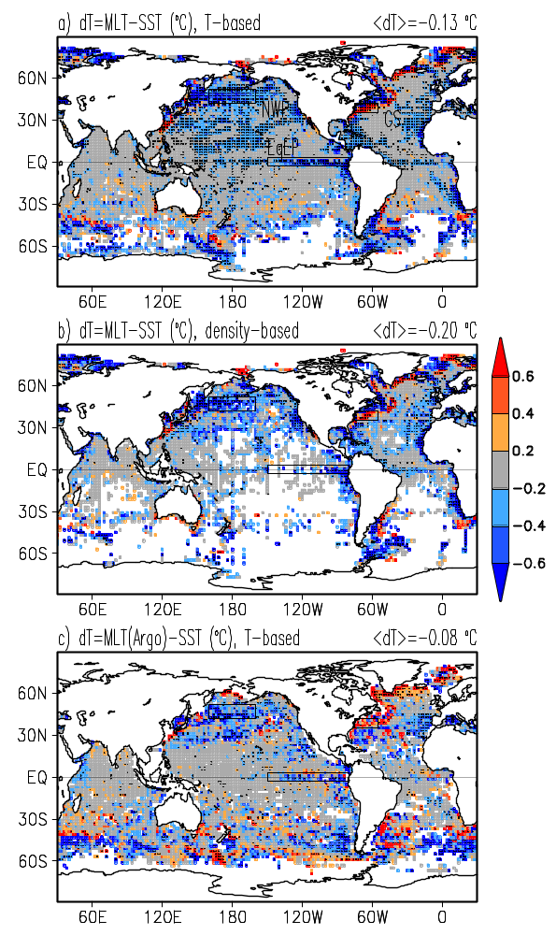
Figure 1. Time mean difference, =MLT-SST, of mixed layer averaged temperature, MLT, and bulk SST from HadISST1. Panels (a) and (b) show MLT from WOD05 based on temperature-based and density-based mixed layer depth, respectively. Grid points with less than one year of data aren’t shown. (c) Argo float MLT difference from bulk SST at grid points with at least 6 months of data. Grid points where magnitude of exceeds standard deviation of are dotted. 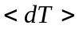 is the global and time mean difference.
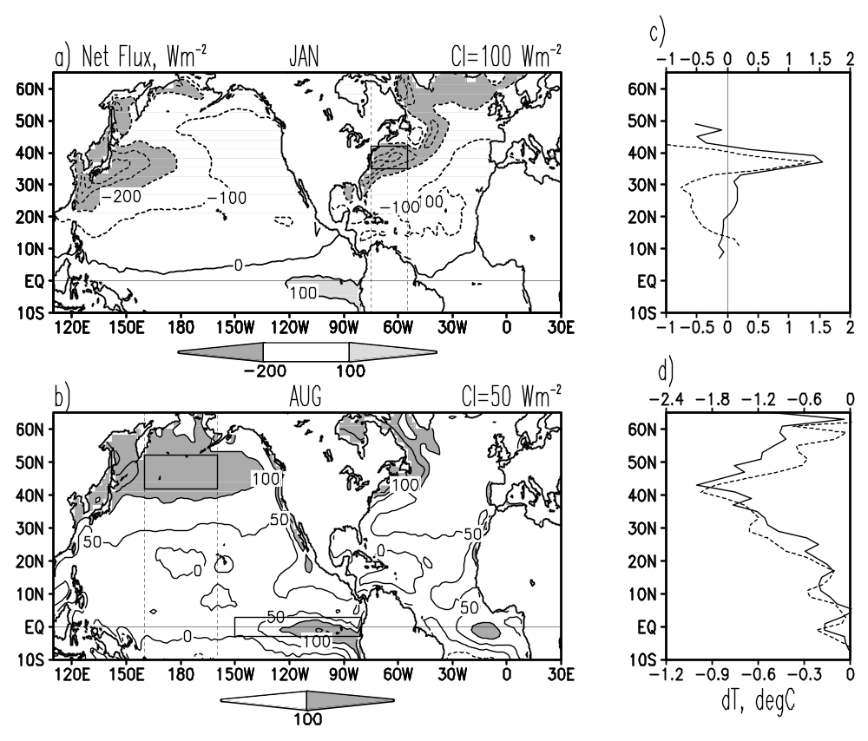

Figure 2. (Left) Climatological net surface heat flux for (a) January, (b) August (positive is heat gain by the ocean). Boxes show the same areas as in Fig.1. (Right, c/d) =MLT-SST zonally averaged over longitude belts shown in the left panels. Solid lines show result of this study (against bottom x-axis) while dashed lines show results based on depth estimates of Lorbacher et al. [2006] (against top x-axis) that is based on the gradient-based definition of the mixed layer depth.

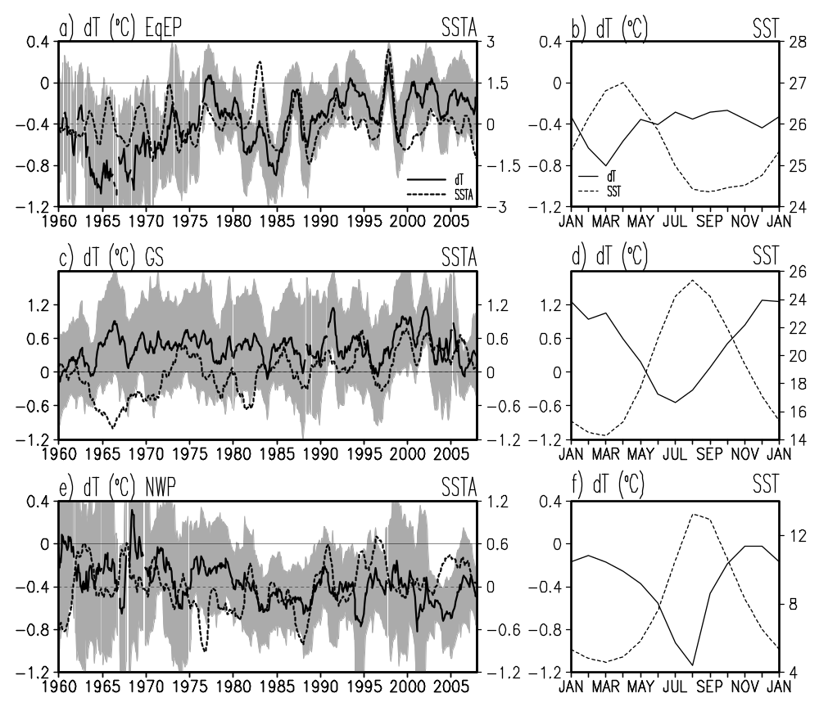

Figure 3. (a), (c) ,(e) Time series of annual running mean box-averaged , standard deviation of (shading), and anomalous SST for the equatorial east Pacific, Gulf Stream, and northwestern Pacific. (b), (d), (f) Seasonal cycle of box-averaged and SST based on HadISST1 data. Time series combine evaluated from WOD05 data through 2004 and Argo data afterwards.
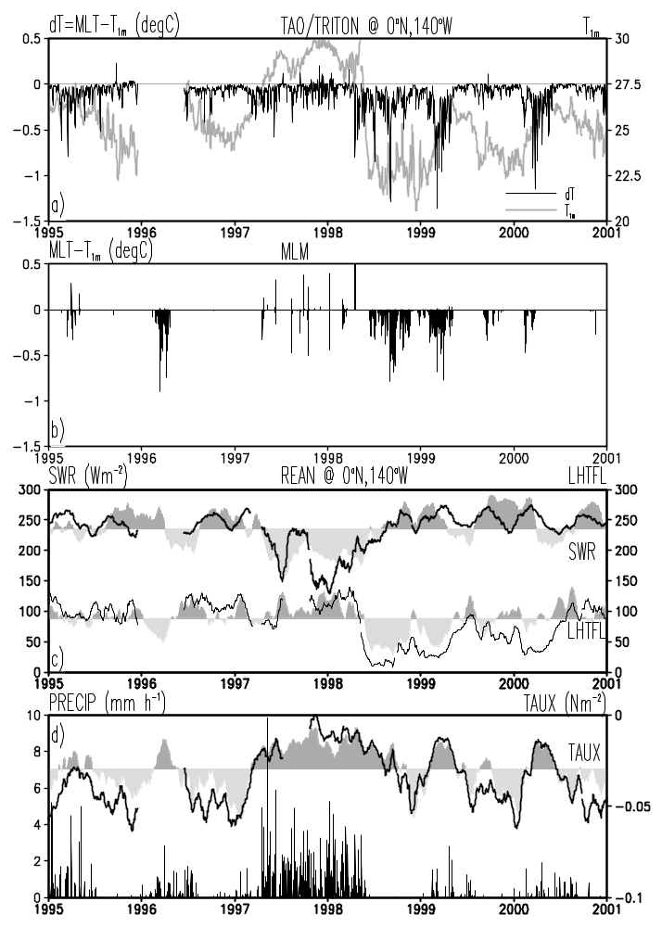
Figure 4. (a) Time series of 1m temperature, 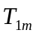. Mixed layer temperature gradient, MLT-, from (a) TAO/TRITON mooring at 0°N, 140°W and (b) mixed layer model (MLM). (c) Monthly running mean shortwave radiation (SWR) and latent heat flux (LHTFL), (d) 6-hour precipitation (PRECIP) and monthly zonal wind stress (TAUX) from the atmospheric reanalysis (shaded) and the mooring (solid).
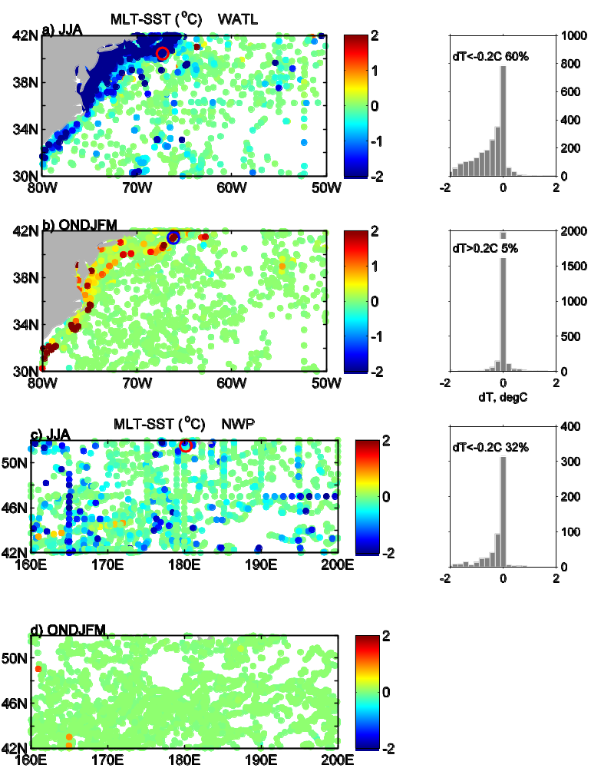
Figure 5. during June-August (JJA) and October-March (ONDJFM) evaluated from individual CTD and Argo profiles in (a,b) Gulf Stream area, (c,d) northwestern Pacific. Circles mark locations of vertical profiles shown in Figs. 6 and 8. Right panels show histograms of based on CTD data. Percentage of grid points with exceeding given threshold is also indicated in histograms.

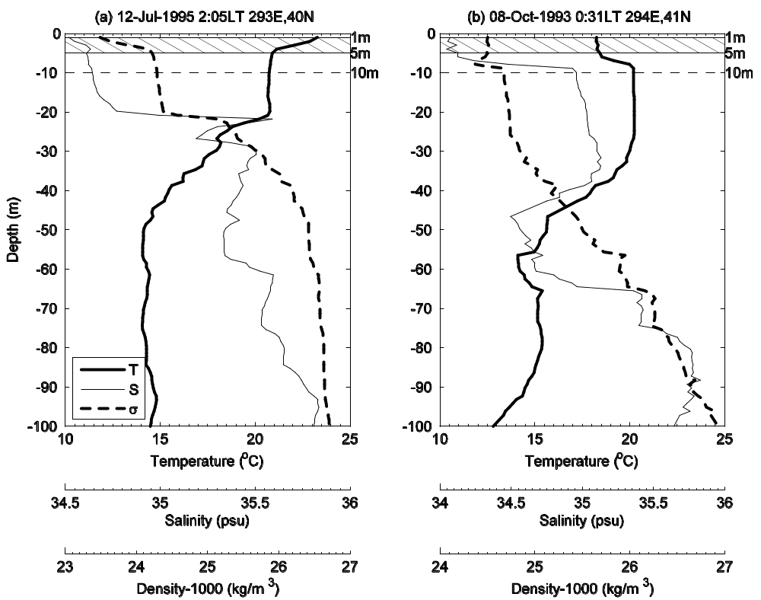

Figure 6. Sample temperature, salinity, and density profiles of with (a) negative and (b) positive MLT-SST. Profiles are taken in the northwestern Atlantic in (a) summer and (b) fall at locations shown in Figs. 5a and 5b, respectively. ‘LT’ indicates the local sun time. Depth range between 1m and 5m is cross-hatched.
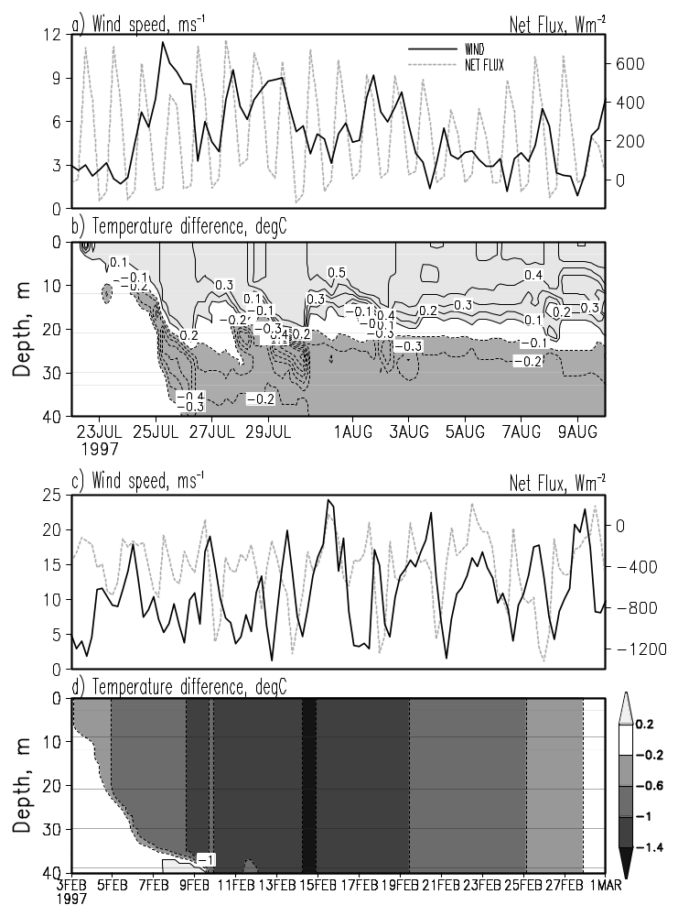

Figure 7. Mixed layer model response to sample winds and net surface flux in the Gulf Stream area in (a,b) summer and (c,d) winter as a function of salinity stratification. Panels (b) and (d) show temperature difference between experiment 2 and experiment 1. These two experiments have the same surface forcing, the same vertically uniform temperature initial conditions, but different salinity initial conditions. In the first experiment initial salinity is vertically uniform while in the second initial salinity has a uniform vertical gradient, 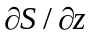=0.1 psu m⁻¹.

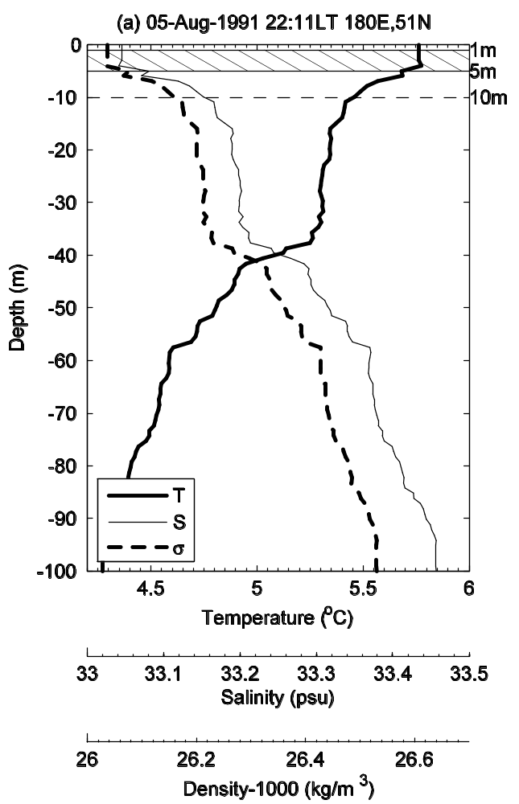
Figure 8 Sample temperature, salinity, and density profiles taken in the northwestern Pacific in summer at location shown in Fig. 5c. ‘LT’ indicates the local sun time.
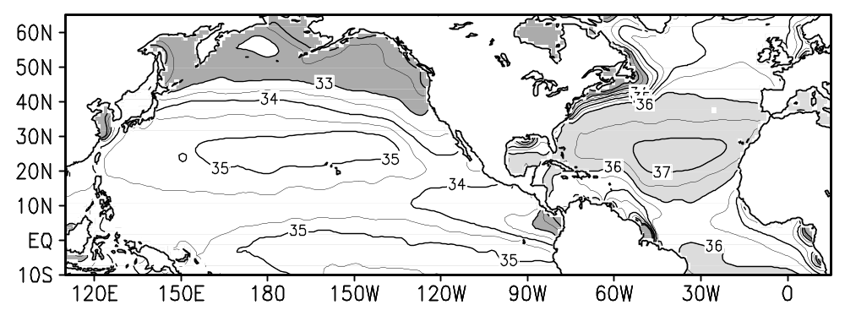

Figure 9. Time mean surface salinity (psu) from the WOD05. Salinities above 36 psu and below 33 psu are shaded.

See the GODAE Global High Resolution SST Pilot Project at http://www.ghrsst-pp.org/SST-Definitions.html
TAO/TRITON moorings measure SST at z=1m. Time mean difference of from HadISST1 at 0°N, 140°W is -0.3C while time correlation is 0.96.

