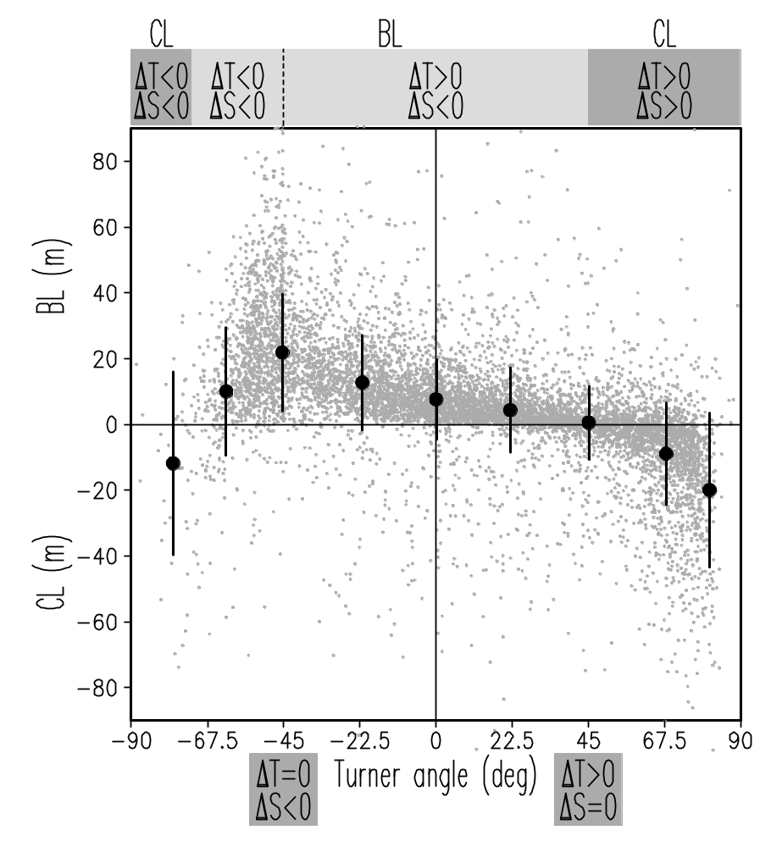
Figure 1. Observed climatological winter-spring barrier layer/compensated layer width versus bulk Turner angle evaluated using temperature (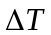) and salinity (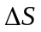) difference between the top and bottom of a barrier or compensated layer. Vertical bars show the mean and the standard deviation for consecutive 22.5⁰ intervals. Grey dots show January-March data from the Northern Hemisphere and July-September data from the Southern Hemisphere. The Turner angle range -72⁰ to 45⁰ corresponds to barrier layer. Compensated layer occurs outside this interval.
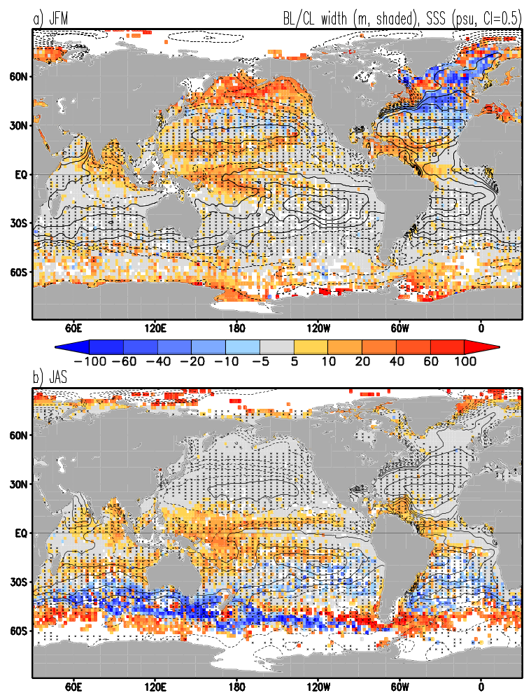
Figure 2. Observed climatological (a) January-March and (b) July-September barrier layer width (positive) and compensated layer width (negative). Climatological SSS (Boyer et al., 2006, contours), SSS35 psu (solid), SSS<35 psu (dashed). Areas of downward Ekman pumping are cross-hatched. Ekman pumping is evaluated from the QuikSCAT scatterometer winds of Liu (2002).

Figure 3. Observed (a,b) salinity () and (c,d) temperature () difference between the top 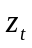= min[MLT, MLD] and bottom 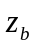=max[MLT, MLD] of barrier/compensated layer, (e,f) bulk Turner angle calculated from and between the same two depths. (left) January - March (JFM) values, (right) July - September (JAS) values. Turner angles in the range from -72º to 45º correspond to barrier layers, while compensated layers occur outside this range.
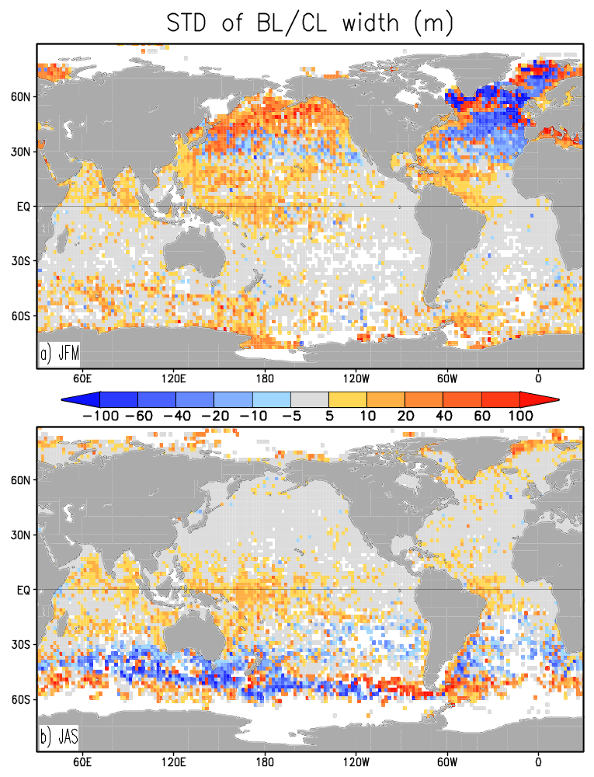
Figure 4. Standard deviation (STD) of observed (a) January-March (JFM) and (b) July-September (JAS) averaged BL/CL width. To contrast variability of barrier layer and compensated layer width, STD deviation is multiplied by the sign of corresponding 3-month average climatological BL/CL width. So the STD of barrier layer/compensated layer width is positive/negative, respectively. All values are computed from 1960-2007 data.
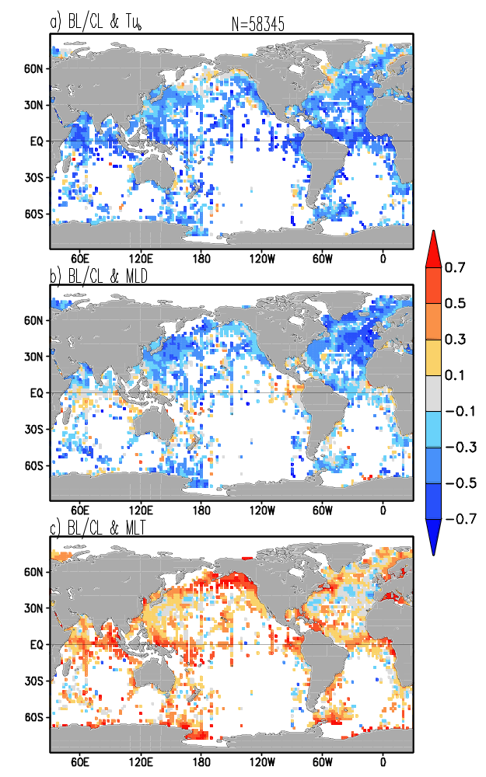
Figure 5. Time correlation of January-March average (a) BL/CL width and bulk Turner Angle, (b) BL/CL and density based mixed layer depth, (c) BL/CL and temperature based mixed layer depth. N is the total number of JFM average binned observations during 1960-2007. Correlations are shown only at grid points where at least 6 observations are available. Time correlation at every grid point is not significant, only large scale patterns matter.

Figure 6. Quasi-decadal average barrier layer (positive) and compensated layer (negative) width in (left) northern winter and (right) austral winter. Units are meters. Rectangles show locations of the North Pacific barrier layer box (NP/BL 160ºE-150ºW, 45º-60ºN), and the North Pacific compensated layer box (NP/CL 140ºE-160ºW, 25º-42ºN). Bottom row shows 1991-2007 averages based on the WOD05 data, that doesn’t include most of recent Argo data. 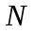is the number of 3-month average observations accumulated during each 15 year period over the global ocean. There are a total of 11,000 ocean grid points on a 2ºx2º grid.
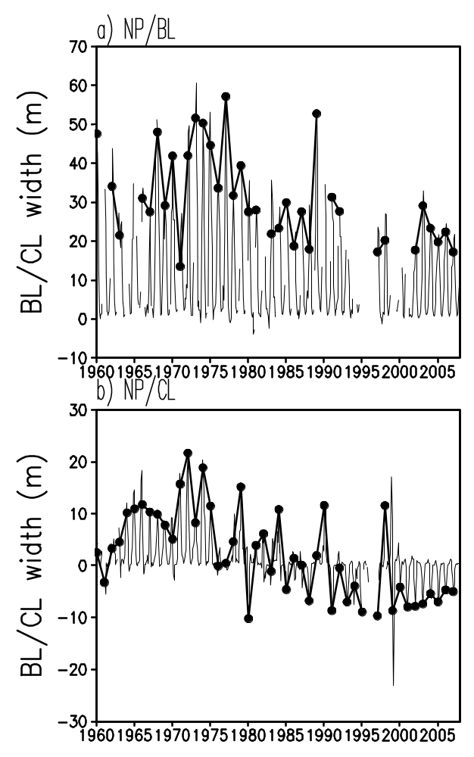
Figure 7. Box averaged BL/CL width in the (a) North Pacific barrier layer region, (b) North Pacific compensated layer region. Thin lines are 3-month running mean, bold lines are January-March averages. Data are shown if at least 10 measurements are available for box averaging. See Fig.6 for box locations.
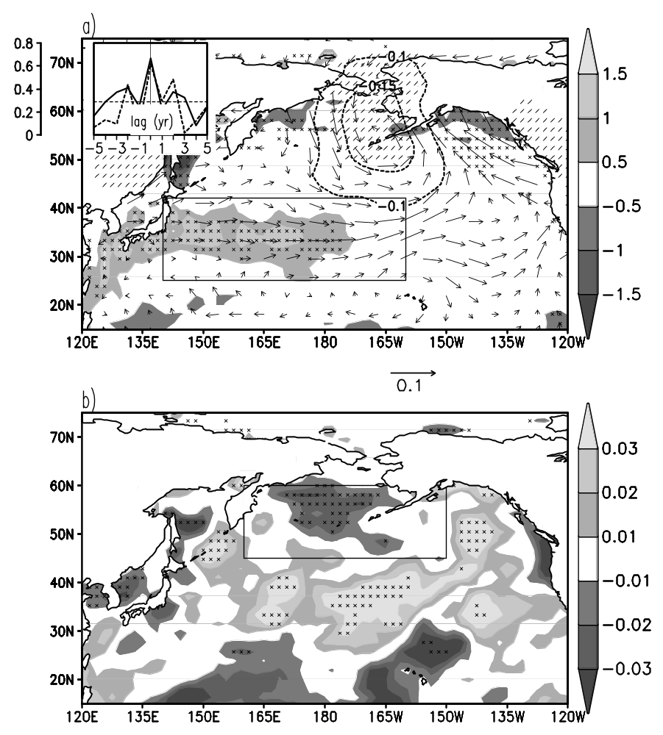

Figure 8. Linear time regression of observed 1960-2007 anomalous JFM BL/CL width in the North Pacific compensated layer box (see panel a) on anomalous (a) latent heat flux (Wm⁻²/m, shading), 10m winds (ms⁻¹/m, arrows), mean sea level pressure (mbar/m, contours) and (b) surface precipitation rate (mm h⁻¹/m) elsewhere. BL/CL width time series is inverted, so that regressions correspond to widening of CLs and shrinking of BLs. Areas where time correlation with latent heat flux and precipitation is significant at the 95% level are ‘X’-hatched while similar areas for air pressure are ‘/’-hatched. Inlay shows lagged correlation of anomalous inverted BL/CL width and MLD averaged over (solid) the NP/CL box and (dashed) the NP/BL box. The two box locations are shown in a) and b), respectively. Dashed line is the 95% confidence level of zero correlation. Positive correlation at zero lag implies that CL thickens and BL thins when the mixed layer deepens. Atmospheric parameters are provided by the NCEP/NCAR reanalysis of Kalnay et al. (1996).
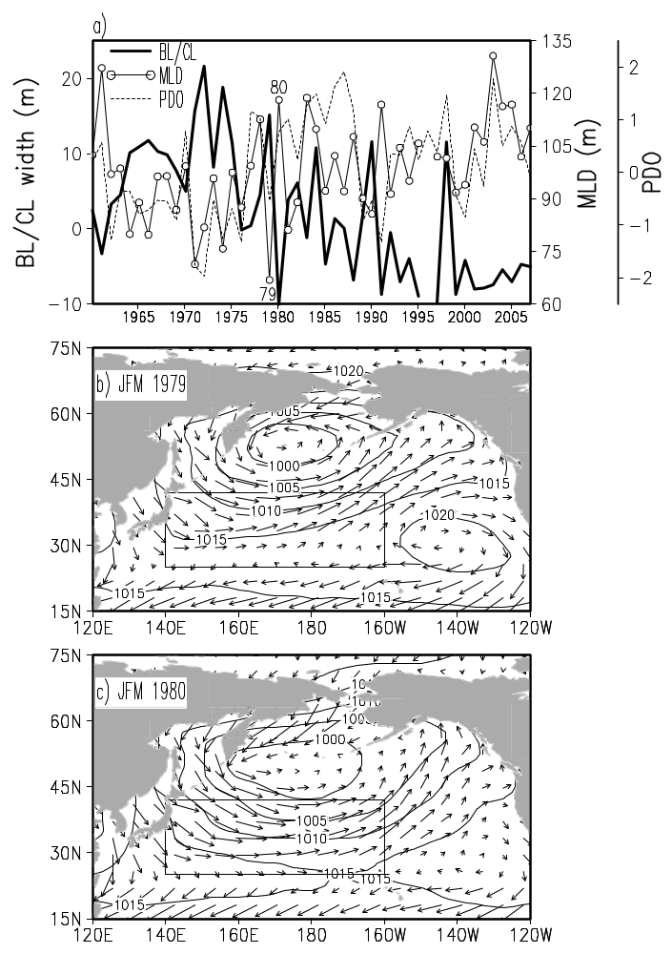
Figure 9. (a) Times series of JFM BL/CL width and MLD averaged over the NP/CL box, and the PDO index. Data is shown for years with at least 10 measurements available for box averaging. JFM winds and mean sea level pressure (mbar) for years of (b) thin and (c) thick compensated layer. Atmospheric parameters are provided by the NCEP/NCAR reanalysis of Kalnay et al. (1996).
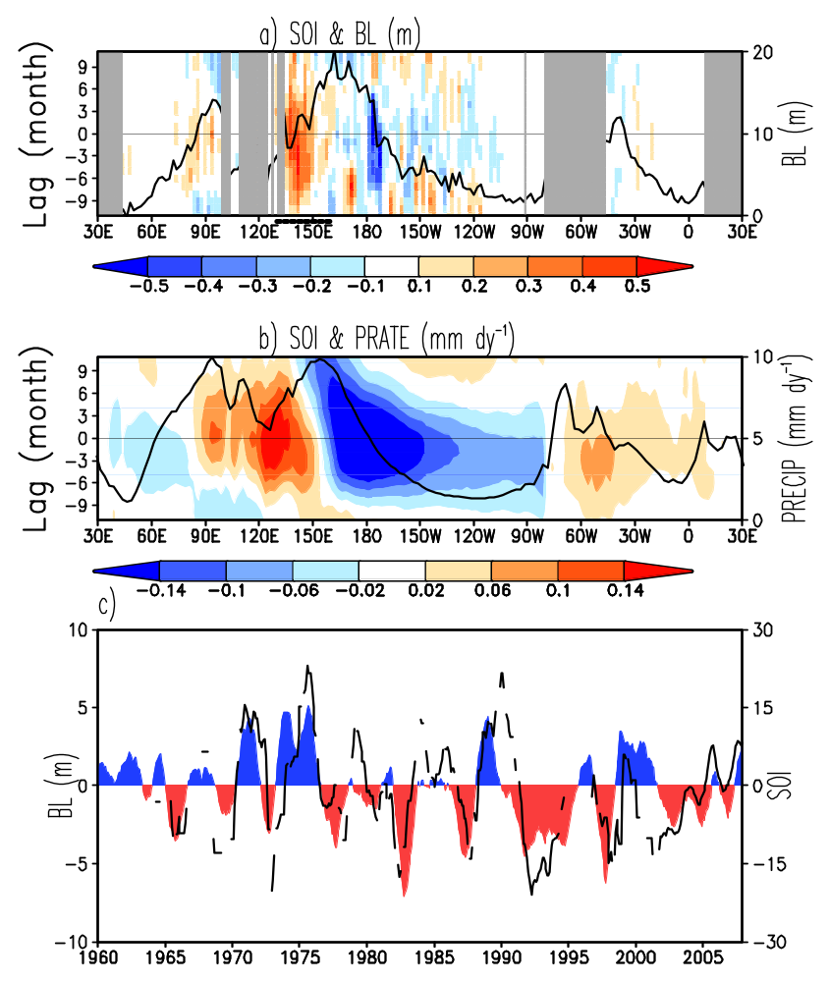

Figure 10. Lag regression of SOI on 5ºS-5ºN averaged (a) anomalous barrier layer width, (b) precipitation (Xie and Arkin, 1997). Lag regressions show magnitude in response to 1 unit change of SOI. Solid lines in (a) and (b) are time mean BL width and precipitation. Longitude bands corresponding to land are shaded gray in (a). (c) Time series of annual running mean SOI (shaded) and anomalous BL width averaged over 130ºE-160ºE, 5ºS-5ºN. Data are shown if more than 10 measurements are available for area averaging.

