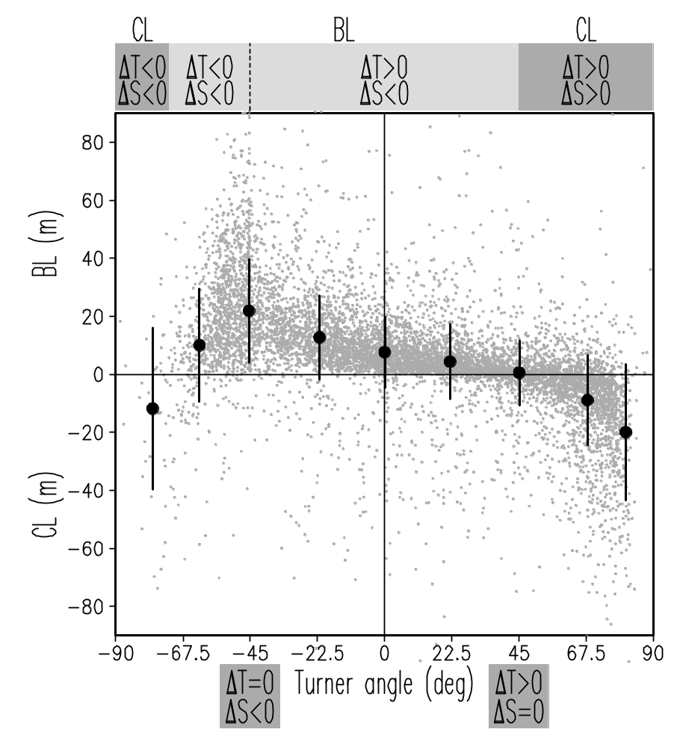
Figure 1. Climatological cold season barrier layer/compensated layer thickness versus the bulk Turner angle evaluated using temperature (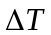) and salinity (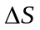) difference between the top and bottom of a barrier or compensated layer. Vertical bars show the mean and the standard deviation for consecutive 22.5⁰ interval of the Turner angle. Grey dots are the cold season data that aggregate January-March data from the Northern Hemisphere and July-September data from the Southern Hemisphere. The Turner angle range -72⁰ to 45⁰ corresponds to BL. CL occurs outside this interval.
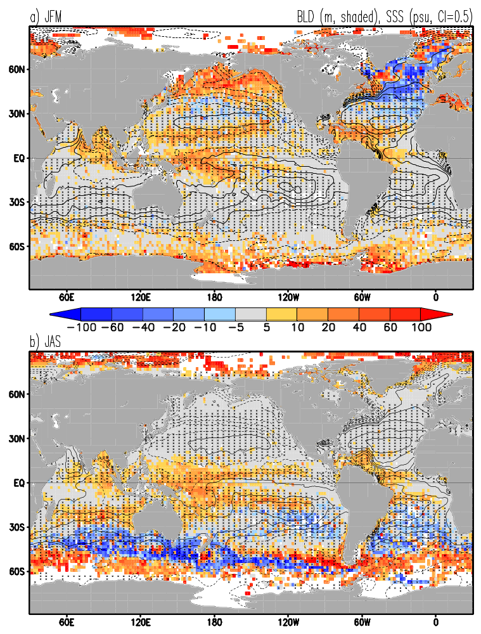
Figure 2. Climatological (a) January-March and (b) July-September barrier layer width (positive) and compensated layer width (negative). Climatological sea surface salinity (35 psu solid contours, below 35 psu dashed contours) and downward wind-driven vertical velocity (hatching) are overlain. Salinity data are from Boyer et al. (2006).

Figure 3. (a,b) Salinity () and (c,d) temperature () difference between the top 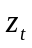= min[MLT, MLD] and the bottom 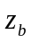=max[MLT, MLD] of barrier/compensated layer, (e,f) bulk Turner angle calculated from and between the same two depths. (left) January - March (JFM) values, (right) July - September (JAS) values. Turner angles in the range from -72º to 45º corresponds to barrier layers, while compensated layers occur outside this range
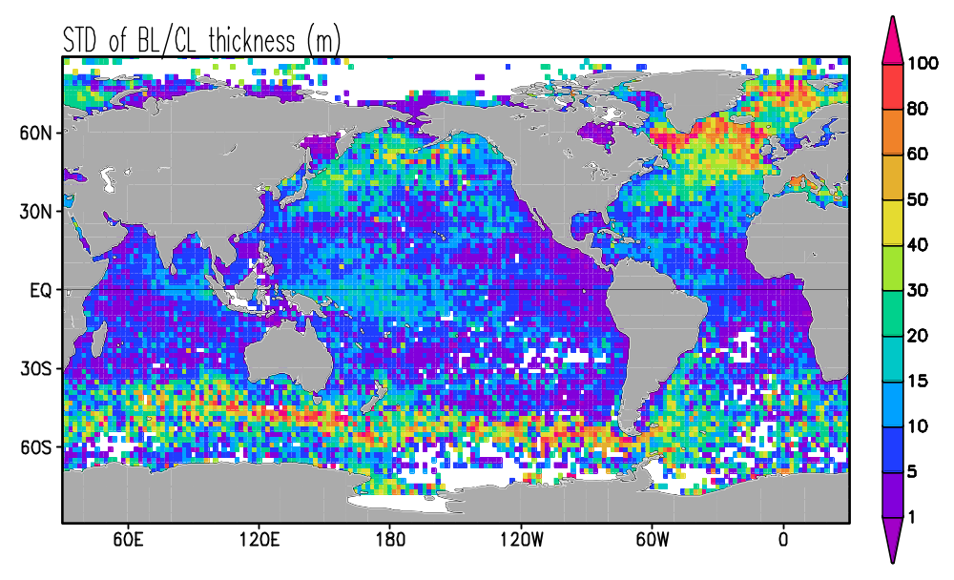
Figure 4. Standard deviation (STD) of monthly anomalous BL/CL thickness.

Figure 5. Quasi-decadal mean barrier layer (positive) and compensated layer (negative) thickness in (left) northern winter and (right) austral winter. Rectangles in (c) show locations of the North Pacific barrier layer box (NP/BL 140ºE-140ºW, 50º-60ºN), North Pacific compensated layer box (NP/CL 140ºE-160ºW, 25º-35ºN), equatorial Pacific barrier layer box (EP/BL 120ºE-160ºE, 5ºS-5ºN), and North Atlantic compensated layer box (NA/CL 30ºW-10ºW, 40º-60ºN)
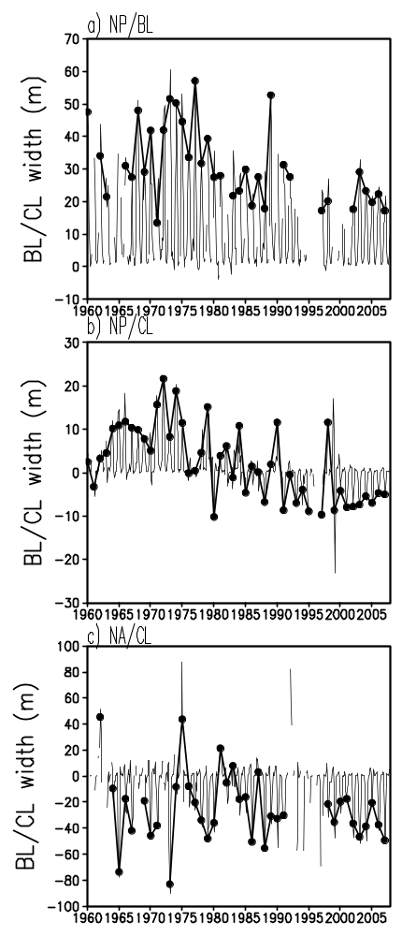

Figure 6. Box averaged BL/CL width in (a) North Pacific barrier layer region, (b) North Pacific compensated layer region, and (c) North Atlantic compensated layer region. Thin lines are monthly average values, bold lines are January-March average values. JFM values are shown if at least 10 data points are available. Box locations are shown in Fig. 5c.
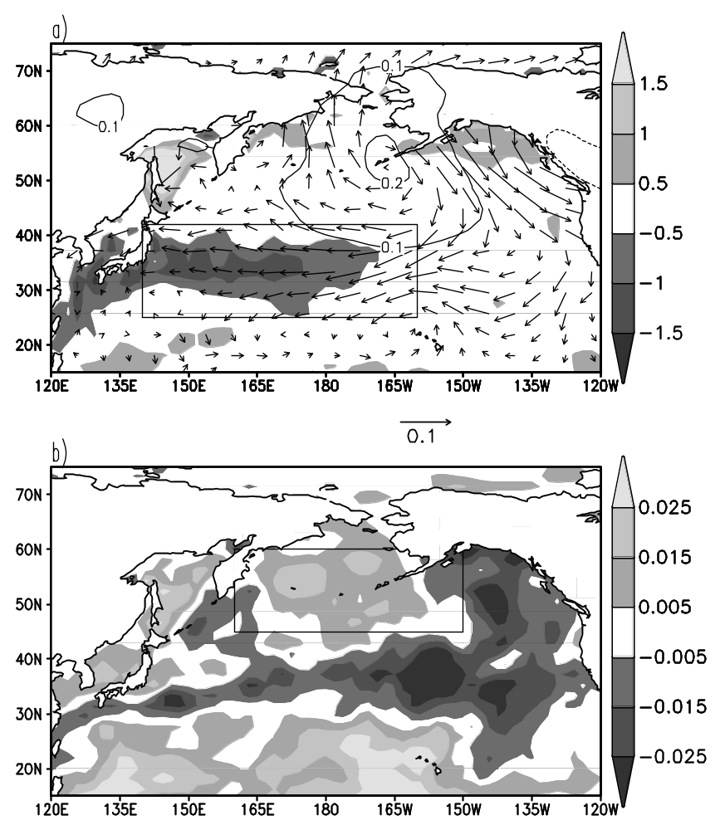

Figure 7. Time regression of JFM barrier layer thickness in (a) North Pacific compensated layer box on latent heat flux (Wm⁻²/m, shading), winds (ms⁻¹/m, arrows), and sea level pressure (mbar/m); (b) North Pacific barrier layer box on precipitation (mm h⁻¹/m). See also Fig.5c for box locations. Atmospheric parameters are from the NCEP/NCAR Reanalysis.

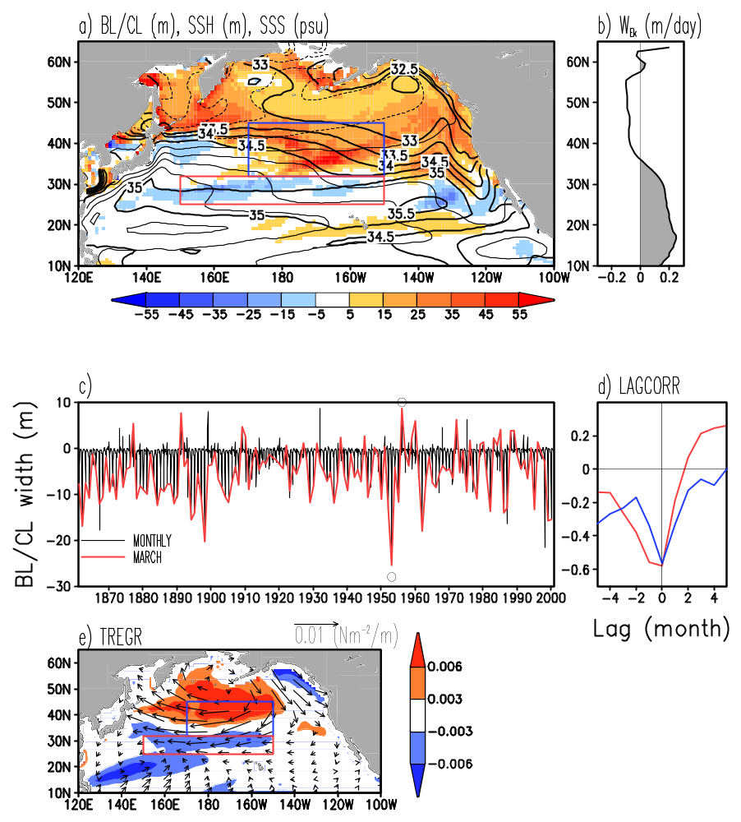
Figure 8. CM2.1 model simulations in the north Pacific. (a) March climatological BL/CL width with climatological sea surface height (SSH, CI=0.2m) and sea surface salinity (SSS, bold contours) overlain. CL and BL boxes are drawn in red and blue, respectively. (b) Zonally averaged March climatological Ekman pumping (positive – downward is shaded gray). (c) Time series of the box-averaged CL width. Two contrasting model years with thick (1953) and thin (1956) CL are marked by ‘o’. (d) Lagged correlation of anomalous (blue) box-averaged CL width and MLD, (red) box-averaged BL width and MLD. (e) Time regression of March box-averaged CL width on wind stress and Ekman pumping (mdy⁻¹/m).
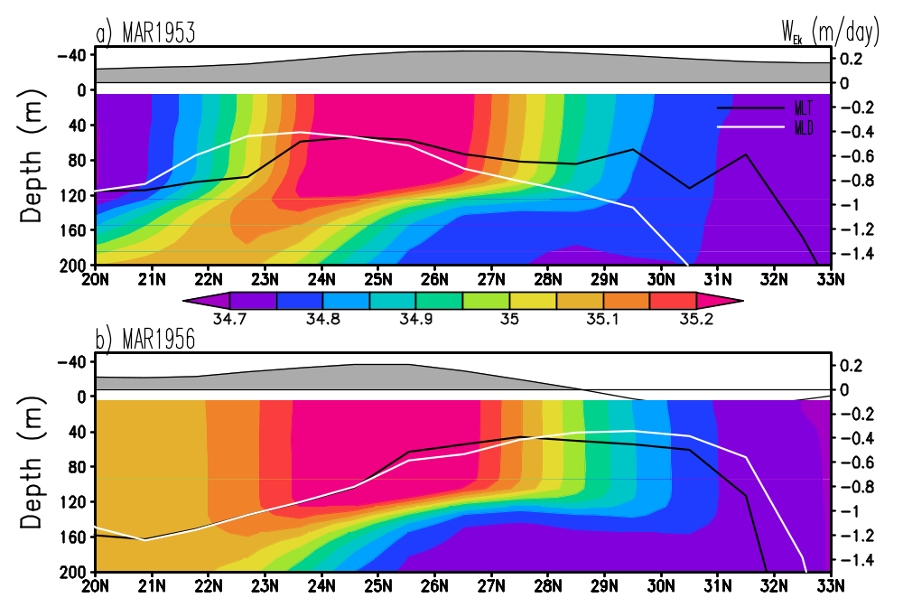
Figure 9. Latitude-depth section of salinity along 180ºE for March of the two contrasting model years with thick (1953) and thin (1956) CL. Ekman pumping (positive – downward is shaded gray) is shown against the right-hand vertical axes.
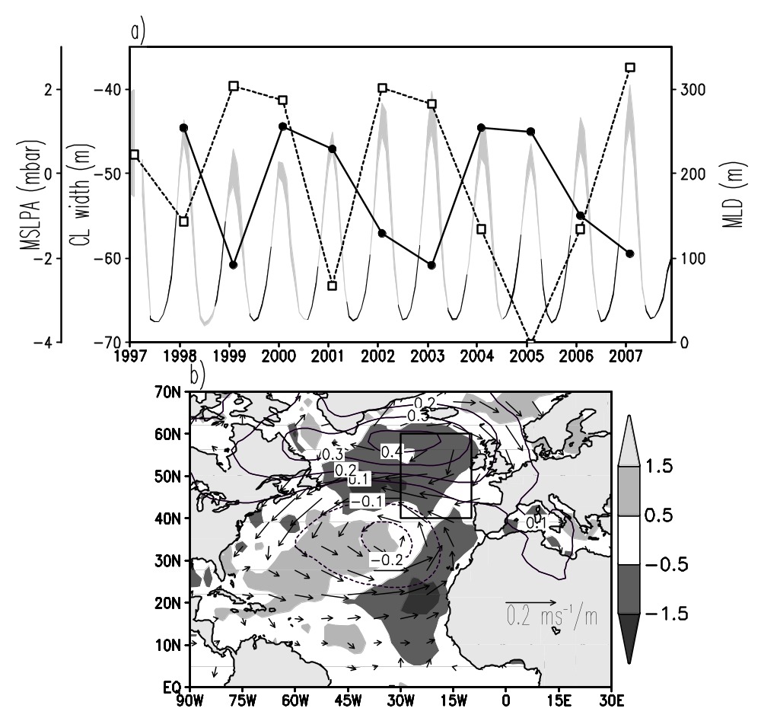

Figure 10. (a) JFM compensated layer width (solid) and monthly mixed layer depth (compensated layer depth range between MLT and MLD is shaded) averaged in the North Atlantic compensated layer box, JFM anomalous mean sea level pressure (dashed) averaged 40W-30W, 30N-40N. (b) Time regression of the 1997-2007 JFM compensated layer width on latent heat flux (Wm⁻²/m, shaded), anomalous mean sea level pressure (mbar/m, contours), and winds (ms⁻¹/m, arrows).
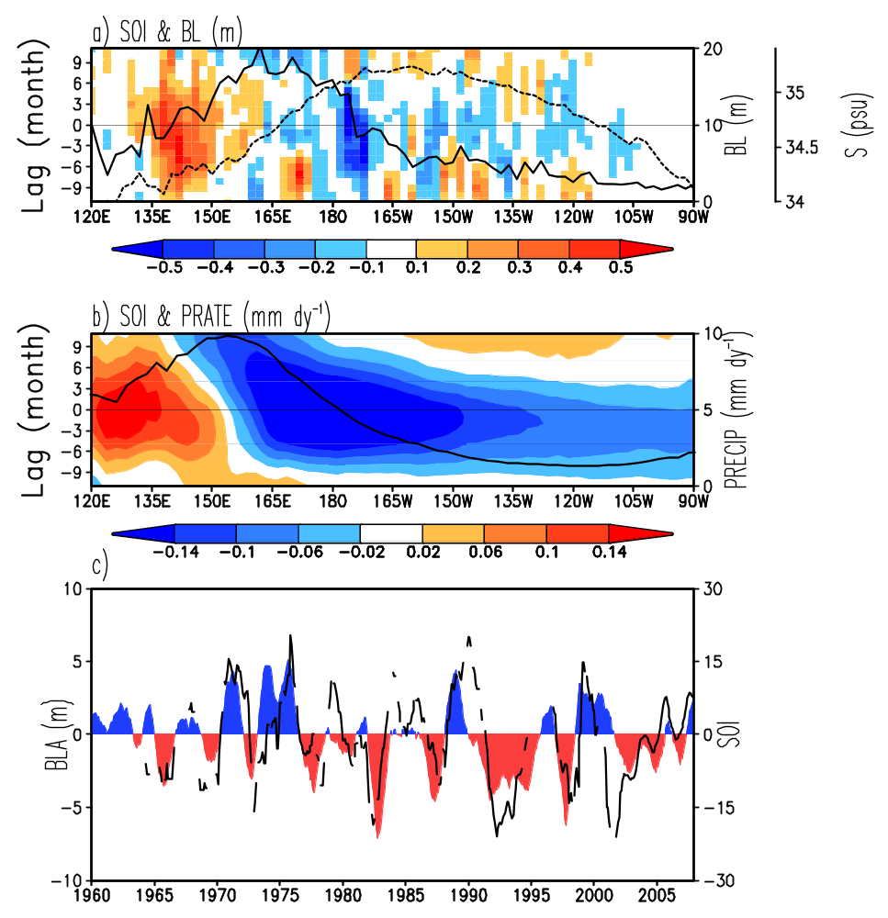

Figure 11. Lag regression of SOI index on 5S-5N averaged (a) anomalous barrier layer width, (b) precipitation. Time mean BL width (solid), salinity(dashed), and precipitation are shown against right hand vertical axes. Precipitation is Xie and Arkin (1997). (c) Time series of annual running mean SOI (shaded) and anomalous BL width averaged in the western equatorial Pacific box (120E-160E, 5S-5N). See Fig. 5c for the box location.

